COS10007 Developing Technical Software TP 2 2022

Assignment 2 report

Name: Son Nguyen , Student ID:103234103

Lab class: Tuesday/10:30/TC212 Teacher: Nalin Randeniya

Due Date: Monday 15th of May 2023 at 11:59 PM

Date Submitted: Monday 15th May 2023 at 5:00pm

Question 1

Program description
It’s a program that use open a file containing data for a set of data. The program then proceeds to ask us what we want to do with this data through the menu command. If we want to display it or do a numerous thing upon it which would be sorting via insertion or bubble sort. It also allows us to search for the data within the array from the open file or insert a new element into the list. If none of the above is what is needed , the program also offer an exit button.

Inputs and Outputs
The inputs and outputs for this program are described in Table 1.

Table 1. Data dictionary:
Data to be stored | Sample data | Type of data | C type | Input method | In /  Out | Variable name
option | 1,2,3,4,5 | Number: 1-5 | Int | scanf | printf | 1,2,3,4,5
Sort | “ascending”  “descending” | Char: A or D | Char | Scanf | Printf | A or D
SortAlgoChoice | “bubble”  “insertion” | Char: B or I | Char | Scanf | Printf | B or I
searchOption | “Linear”  “Binary” | Char: L or B | Char | Scanf | Printf | L or B

3. Algorithm
Program steps:
  - Program start by reading the input.txt
  - If text is there, program will proceed to menu screen and if not the message “File does not exist. Exiting program” will be displayed.
  - Menu will be printed to the screen showing 5 options, if user input is not one of the 5 available options , a message will be displayed “Invalid option, try again” and menu will be re-printed for selection
  - If option 1 is pick, the array will be printed onto the screen as requested and then the program will return to the menu.
  - If option 2 is pick, a follow up questions which determine if the array will be sorted in ascending or descending order. Once selected, the option of sorting in bubble or insert is asked. If the correct character isn’t chosen, an invalid message will be asked prompting the user to re-type. Once a correct input is selected – the program will sort and print out into a .txt file the new sorted array.
  - If option 3 is pick, like previous option ; it will ask if the search is in what option , linear or binary. Upon correct selection, it will ask for the string that is required to be search and will print out the result if the string is found.
  - IF option 4 is pick – the program will print the input.txt into a list
  - If option 5 is pick – the program is terminated after a message clarifying the program exit.

Source code:

Please refer to the attached file for the full source code !

Screenshots showing working program (Show all possible outcome):
Option 1
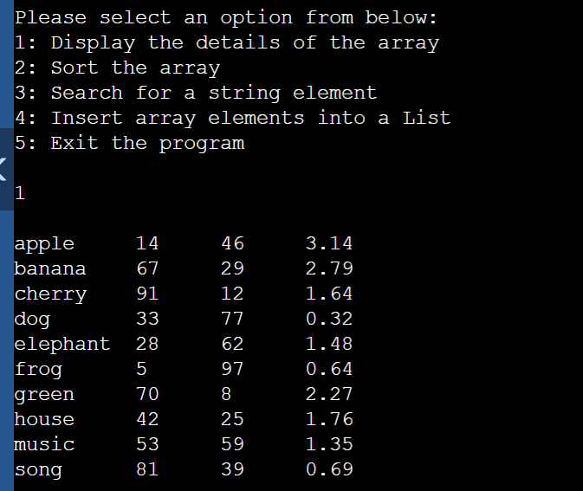
Option 2
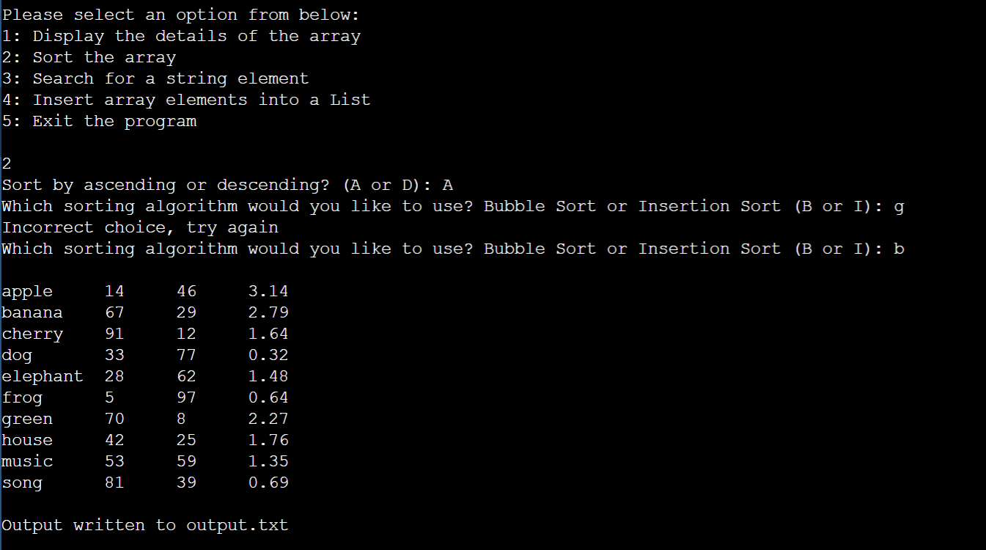
Option 3
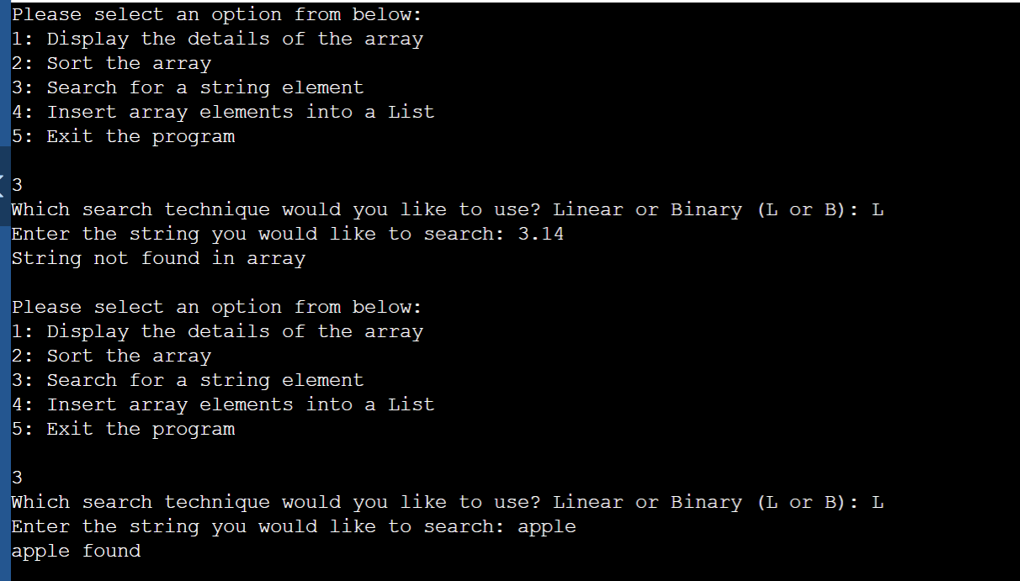
Option 4
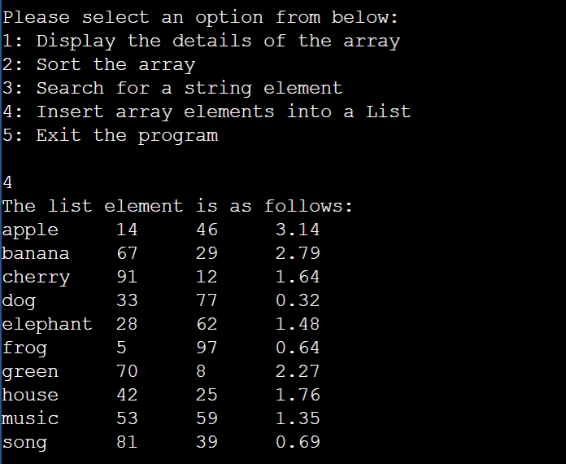

Question 2

Program description
Program use the Luhn’s algorithm to determine the invalid number when it comes to credit card, the program take a set of number entered by the user and determine if the number is valid or not. The program will stop when it encounters a negative number or a double number.

Inputs and Outputs
The inputs and outputs for this program are described in Table 1.

Table 1. Data dictionary:
Data to be stored | Sample data | Type of data | C type | Input method | In /  Out | Variable name
number | “1” | Number 1-9 | Int | scanf | printf | Num

3. Algorithm
Program steps:
  - Program start by asking for an input , up to 20 and state that -1 will end the series
  - The menu will them prompt you to either 20 numbers or until you decie to cancel it
  - The number will then be ran through the Luhn’s algorithm to check its validity and the menu will print out accordingly to the parameters given
  - The number follow the described algorithm

Source code:
#include <iostream>
using namespace std;

int main() {
const int maxSize = 20;
int numbers[maxSize];
int count = 0;

cout << "Enter a series of one-digit positive numbers (-1 to end):" << endl;

// Read numbers until -1 is entered or the array is full
while (count < maxSize) {
int num;
cin >> num;

if (num == -1)
break;

if (num >= 0 && num <= 9) {
numbers[count] = num;
count++;
} else {
cout << "Invalid number! Please enter a one-digit positive number or -1 to end." << endl;
}
}

// Display the entered numbers
cout << "Entered numbers: ";
for (int i = 0; i < count; i++) {
cout << numbers[i] << " ";
}
cout << endl;

int sum1 = 0;
int sum2 = 0;
for (int i = count - 1; i >= 0; i--) {
int digit = numbers[i];

if ((count - i) % 2 == 0) {
int doubledDigit = digit * 2;
if (doubledDigit > 9) {
// Add the digits of the doubled number
doubledDigit = (doubledDigit % 10) + (doubledDigit / 10);
}
sum1 += doubledDigit;
} else {
sum2 += digit;
}
}

int totalSum = (sum1 + sum2) * 9;
int checksum = totalSum % 10;

cout << "Sum of doubled numbers: " << sum1 << endl;
cout << "Sum of all other numbers: " << sum2 << endl;
cout << "Total sum: " << totalSum << endl;
cout << "Checksum: " << checksum << endl;

return 0;
}

Screenshots showing working program (Show all possible outcome):
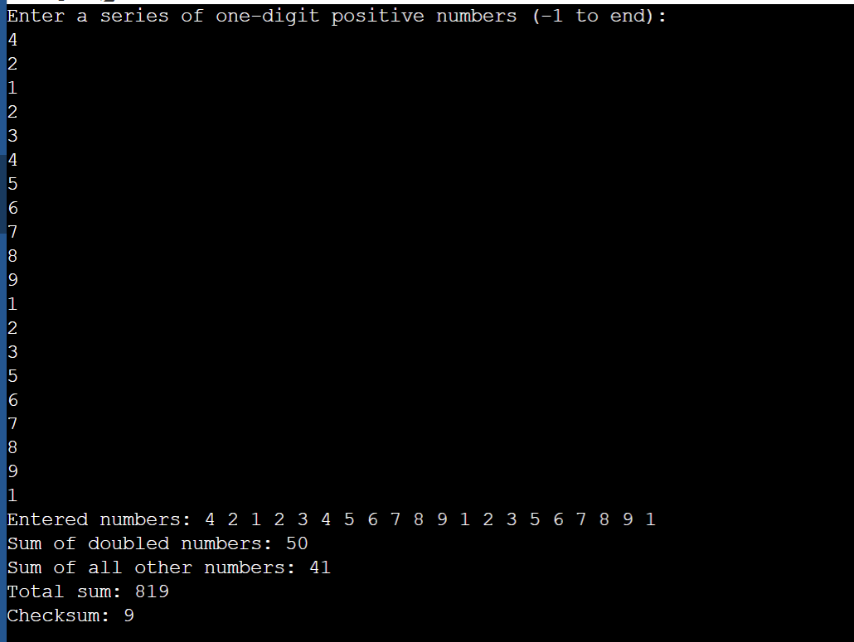

Question 3

Program description

Program deal with online purchase of TVs using queue and dequeue – using first come first served as a basis – the program is to design to , display current stock , add new TV to the linked list , display order (next,current and previous) , adding order , cancel last order. Essentially using queue and de-queue in sequence to add and subtract.

Inputs and Outputs
The inputs and outputs for this program are described in Table 1.

Table 1. Data dictionary:
Data to be stored | Sample data | Type of data | C type | Input method | In /  Out | Variable name
Option | “1,2,3,4,5…” | Char : 1 number (real) | Int | scanf | printf | option
TVName | TVName | Char : 50 letters | String | Scanf | Printf | TVName
TVName | TVName | Char:50 letters | String | Scanf | Printf | TVName

3. Algorithm
Program steps:
- The computer read the text file before loading up the menu , if the text file is not found – program terminate after sending an error message
- If text files is present , the program will prompt a menu for selection
- Out of the presented options , if the input is different from the one presented on the screen , an error message will appear and the menu will be reloaded.
- Option 1 – will display the list of the current stock of the TV.
- Option 2 – will allow the user to input a new TV to stock.
- Option 3 - will display the next order in queue.
- Option 4 – display all the order that is currently in the array.
- Option 5 – add an order into the queue.
- Option 6 – process the next order that is on top of the queue.
- Option 7 – cancel the previous order that was slot into the queue.
- Option 8 – to print the last order to the screen.
- Option 9 – update the text file.
- Option 10 – Quit program.

Source code:

#include <stdlib.h>
#include <stdio.h>
#include <string.h>
#include <ctype.h>
//Data Struct
struct Node{
char TVName[50];
struct Node* next;
};
typedef struct{
struct Node* head;
struct Node* tail;
} Queue;
//set pointer to NULL
void init(Queue* q){
q->head = NULL;
q->tail = NULL;
}
//Queue Data Struct
void enqueue(Queue *q, char* data){
struct Node* new_node = (struct Node*)malloc(sizeof(struct Node));
strcpy(new_node->TVName, data);
new_node->next = NULL;
if (q->head == NULL){
q->head = new_node;
q->tail = new_node;
}
else{
q->tail->next = new_node;
q->tail = new_node;
}

}
// Dequeue Operation
char* dequeue(Queue *q){
if (q->head == NULL){
return NULL;
}
char* data = malloc(sizeof(char) * (strlen(q->head->TVName) + 1));
strcpy(data, q->head->TVName);
struct Node* tempNode = q->head;
q->head = q->head->next;
free(tempNode);
if (q->head == NULL){
q->tail = NULL;
}

return data;
}
//Data Struct for Array
typedef struct{
char* TVStack[100];
int top;
} Stack;

void initStack(Stack* s){
s->top = -1;
}
void push(Stack* s, char* TVName){
if (s->top != 99){
s->TVStack[++(s->top)] = strdup(TVName);
}
}
char* pop(Stack* s){
if (s-> top != -1){
return s->TVStack[(s->top)--];
}
return NULL;
}
char* top(Stack* s){
if (s->top == -1){
return "None\n";
}
else{
return s->TVStack[s->top];
}
}
// read file
void readTVs(struct Node** headNode) {
FILE *fptr;
if ((fptr = fopen("TVs.txt", "r")) == NULL) {
printf("Invalid file, exiting program.");
exit(1);
}
struct Node* node;
int ID;
int isEmpty = 1;
while (!feof(fptr)) {
node = (struct Node*)malloc(sizeof(struct Node));
if (fscanf(fptr, "%d", &(ID)) == EOF) {
break;
}
isEmpty = 0;
fscanf(fptr, " %[^\n]s", node->TVName);
struct Node* prev = NULL;
struct Node* cur = *headNode;
while (cur != NULL && strcasecmp(cur->TVName, node->TVName) < 0) {
prev = cur;
cur = cur->next;
}
if (prev == NULL) {
node->next = *headNode;
*headNode = node;
}
else {
prev->next = node;
node->next = cur;
}
}
fclose(fptr);
if (isEmpty) {
printf("File is empty, exiting program.");
exit(1);
}
}
// Menu
int menu(){
int option;
printf("Select from the following menu options:\n");
printf("1: Display the current stock of TVs\n");
printf("2: Add a new TV to stock\n");
printf("3: Display next order information\n");
printf("4: Display all orders\n");
printf("5: Add order to queue\n");
printf("6: Process the next order\n");
printf("7: Cancel last order\n");
printf("8: Display info of last order\n");
printf("9: Update TV file\n");
printf("10: Quit program\n\n");
int errorCheck;
errorCheck = scanf("%d", &option);
while (errorCheck != 1){
printf("Invalid input, try again\n");
while (getchar() != '\n'){}
errorCheck = scanf("%d", &option);
}
return option;

}
// Insert TV into List
void insertTVintoList(struct Node** headNode, char* TVName){
struct Node* prev = NULL;
struct Node* cur = *headNode;
while (cur != NULL && strcasecmp(cur->TVName, TVName) < 0){
prev = cur;
cur = cur->next;
}
struct Node* newNode;
newNode = (struct Node*)malloc(sizeof(struct Node));
strcpy(newNode->TVName, TVName);
if (prev == NULL){
newNode->next = *headNode;
*headNode = newNode;
}
else{
prev->next = newNode;
newNode->next = cur;
}
}
//Display TV List
void displayTVList(struct Node* node){
printf("Current Stock of TVs are listed below: \n\n");
struct Node* cur = node;
while (cur != NULL){
printf("%s\n", cur->TVName);
cur = cur->next;
}
}
// Display Next Order
void displayNextOrder(Queue *q){
if (q->head == NULL){
printf("The order-list is currently empty.\n");
}
else{
printf("The next order in the list is %s\n", q->head->TVName);
}
}
// Display All Order
void displayAllOrders(Queue *q){
if (q->head == NULL){
printf("The order-list is currently empty.\n");
}
else{
struct Node* node = q->head;
printf("Orders to be executed:\n");
while (node != NULL){
printf("%s\n", node->TVName);
node = node->next;
}
}
}
// Dequeue next TV from queue
void ProcessNextOrder(Queue *q, Stack* s, struct Node** headNode){
char *TVName = dequeue(q);
if (TVName != NULL){
struct Node* cur = *headNode;
struct Node* prev = NULL;
while (cur != NULL && strcasecmp(cur->TVName, TVName) != 0){
prev = cur;
cur = cur->next;
}
if (cur != NULL){
if (prev == NULL){
*headNode = cur->next;
}
else{
prev->next = cur->next;
}
push(s, cur->TVName);
free(cur);
printf("Order successfully processed!\n");
}
else{
printf("TV not found in List\n");
}
}
else{
printf("There are no orders to process.\n");
}

}
// Update file
void updateTVFile(struct Node* headNode){
FILE *fptr;
if ((fptr = fopen("TVs.txt", "w")) == NULL){
printf("Invalid file, exiting program.");
exit(1);
}
if (headNode == NULL){
printf("No TV availiable currently.");
return;
}
struct Node* cur = headNode;
while (cur->next != NULL){
fprintf(fptr, "%s\n", cur->TVName);
cur = cur->next;
}
fprintf(fptr, "%s", cur->TVName);
fclose(fptr);
}
// Main Function
int main(){
struct Node *head = NULL;
Queue OrderQueue;
Stack PrevOrders;
initStack(&PrevOrders);
init(&OrderQueue);
readTVs(&head);
int option = menu();
while (option != 10){
switch(option){
case 1:
displayTVList(head);
break;
case 2:
printf("Input the name of the TV: ");
char TVName[50];
while (getchar() != '\n') {}
fgets(TVName, 50, stdin);
TVName[strcspn(TVName, "\n")] = '\0';
insertTVintoList(&head, TVName);
printf("TV successfully added to the list!");
break;
case 3:
displayNextOrder(&OrderQueue);
break;
case 4:
displayAllOrders(&OrderQueue);
break;
case 5:
printf("Enter the name of the TV you would like to purchase: ");
while (getchar() != '\n'){}
fgets(TVName, 50, stdin);
TVName[strcspn(TVName, "\n")] = '\0';
enqueue(&OrderQueue, TVName);
printf("Order successfully placed!\n");
break;
case 6:
ProcessNextOrder(&OrderQueue, &PrevOrders, &head);
break;
case 7:
char* prevOrderName = pop(&PrevOrders);
if (prevOrderName != NULL){
insertTVintoList(&head, prevOrderName);
printf("Order cancelled successfully\n");
}
else{
printf("There are no previous orders\n");
}
break;
case 8:
printf("The previously processed order is %s\n", top(&PrevOrders));
break;
case 9:
updateTVFile(head);
printf("TVs.txt updated successfully!\n");
break;
default:
printf("Incorrect option. Try again.\n");
break;
}
printf("\n");
option = menu();
}
printf("Exiting program.\n");
return 0;
}

Screenshots showing working program (Show all possible outcome):
Option 1
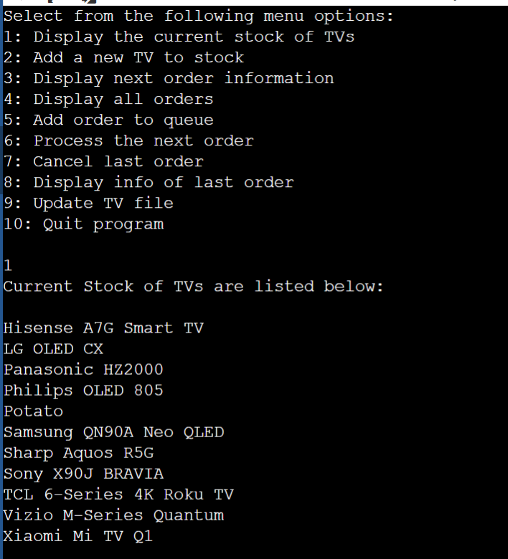
Option 2
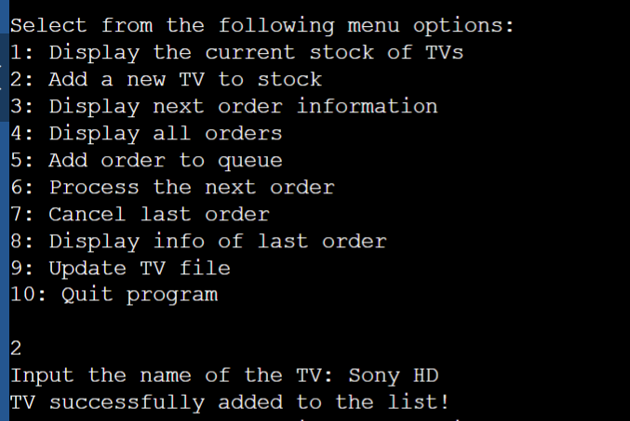
Option 3
